Scheduling a shipment to ZooQuatic Laboratory
- Log into your UPS account. Don’t have one? Please create one at UPS.com.
- On the homepage, select “Ship”
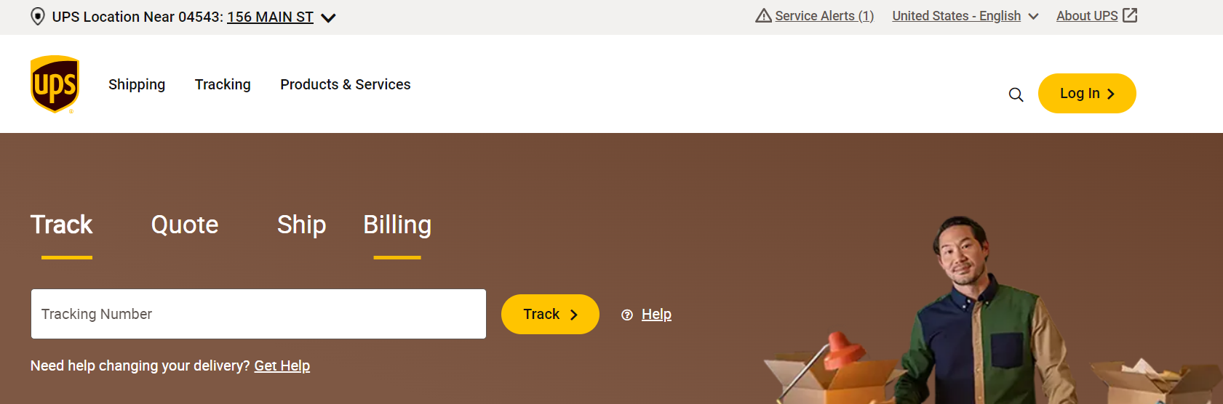
- Enter our address: ZooQuatic Laboratory, 701 E. Pratt St., Baltimore, Maryland, 21202. Note you can save our address for the future.
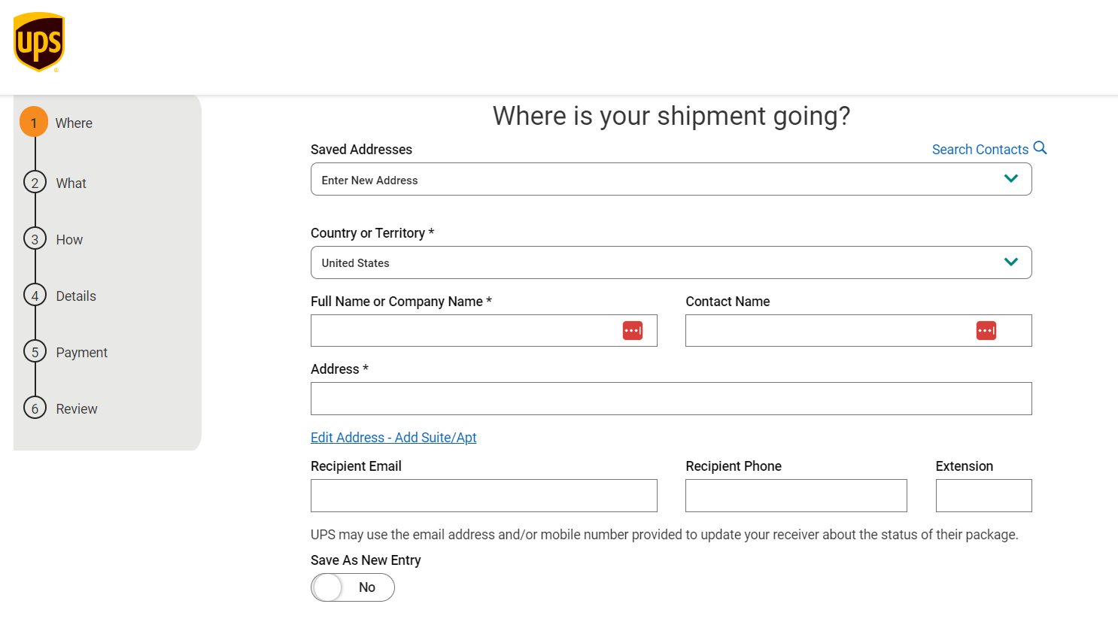

- On the next screen, provide information about your packaging. Use the drop-down menu under “My Packaging” to select your type of packaging. We recommend using UPS Clinical Pak for shipment. The Clinical Pak materials are available from UPS at no charge. Packages typically weigh under 1 lb.
  - Enter weight
  - Enter $100 for the value of the shipment.
  - Check “Add Reference Numbers” and write “AZA Elasmobranch”
  - Check “Use this number for all packages”
  - Select “Continue”
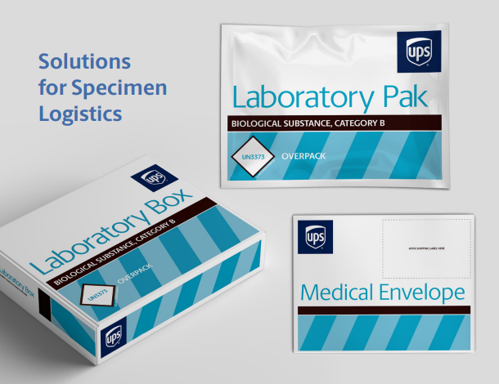 We recommend the Laboratory PAK available from UPS for shipping.
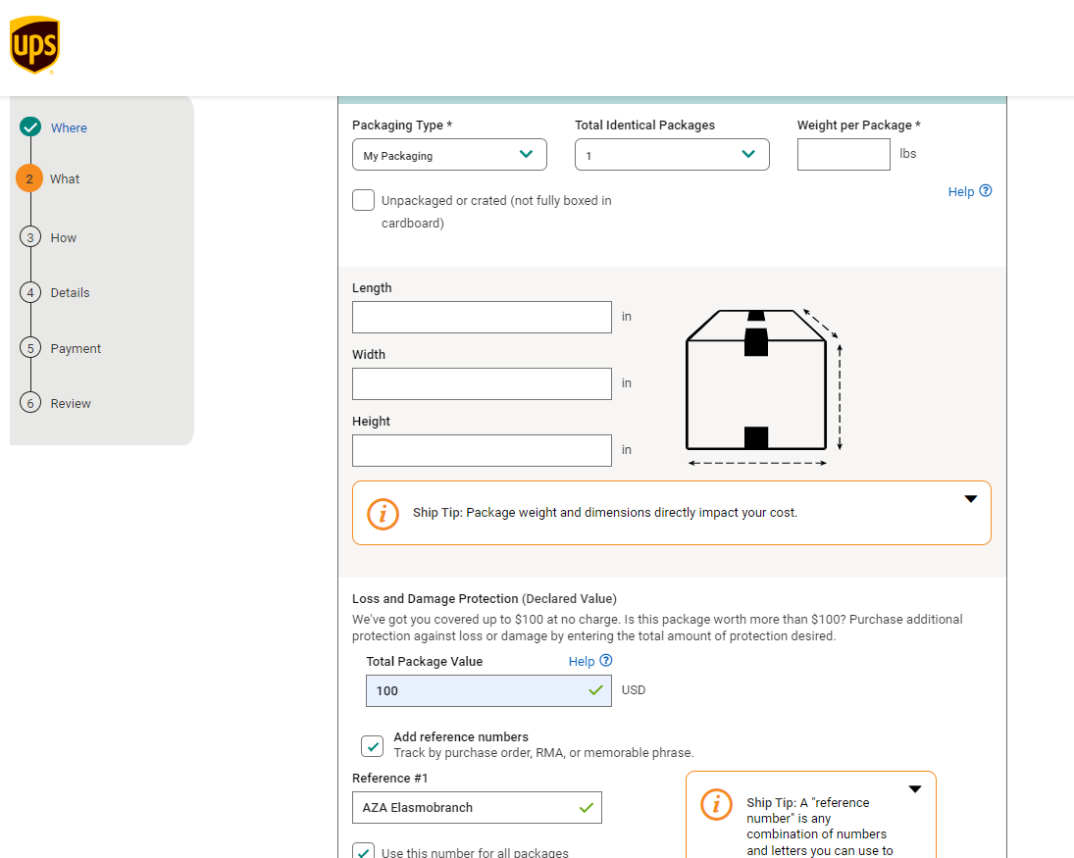

- “How would you like to ship?” You can schedule a pick-up or drop off at a UPS location. Make sure to select “Deliver to receiver”
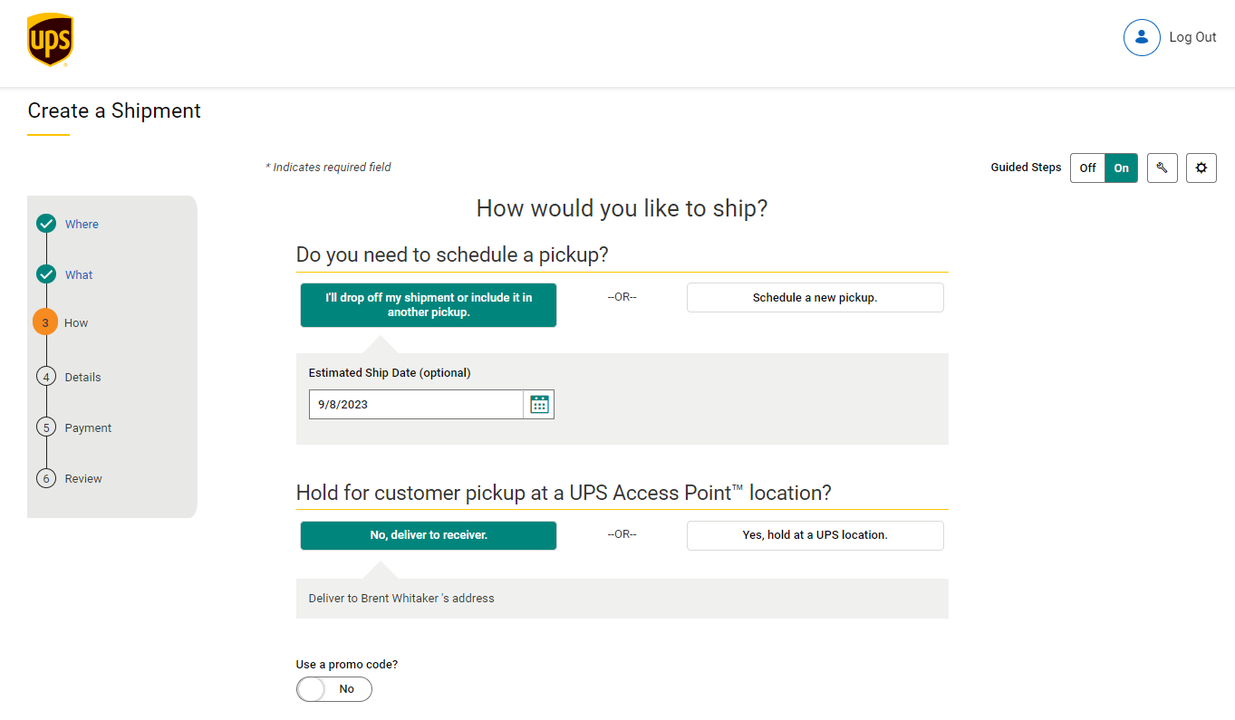
- “When would you like it delivered”. Select “UPS Next Day Air”
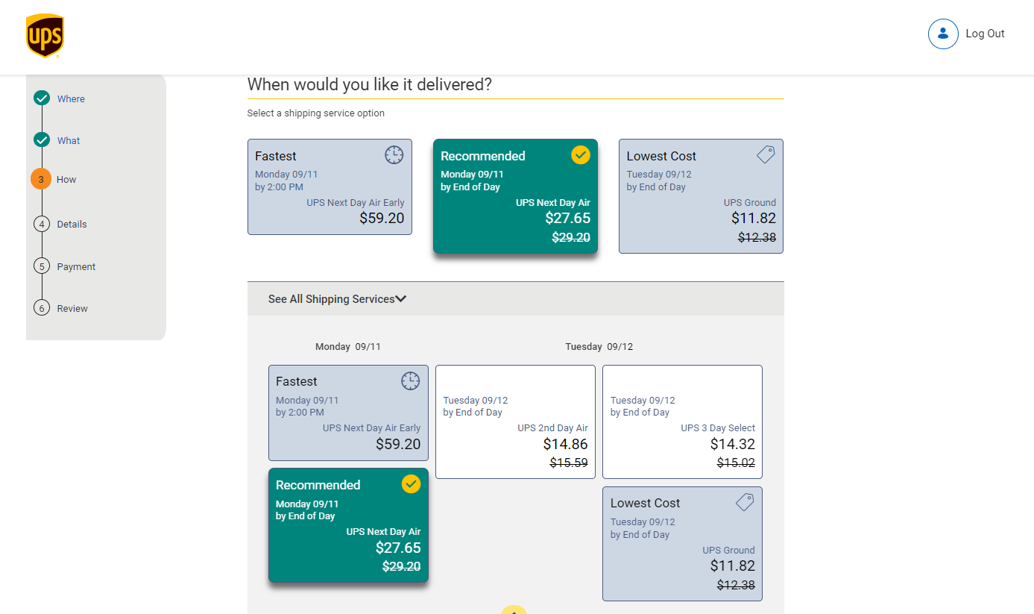

- “How would you like to pay?” Select:
  - “Bill other account”
  - “Receiver”
  - Enter this project’s account number “E522D3” and “21202” for the zip code
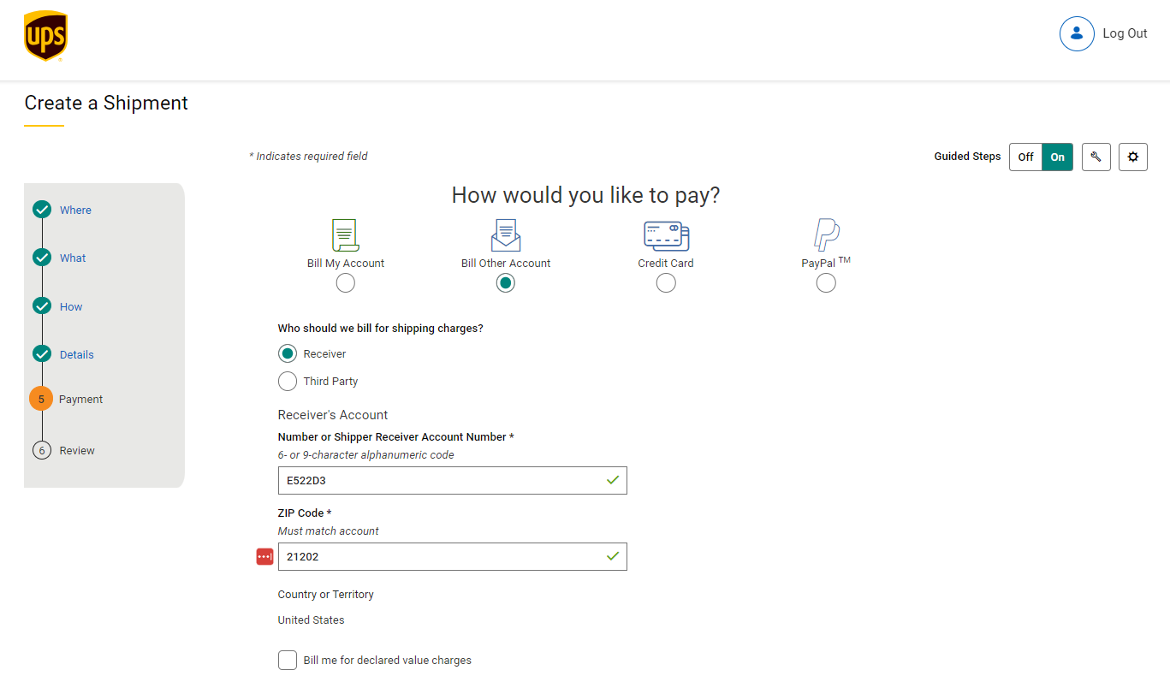
- Continue to “Review” shipment and if all information is correct process shipment and print label.

If you have any questions or challenges with this process, please call Brent Whitaker at 443-604-6363

