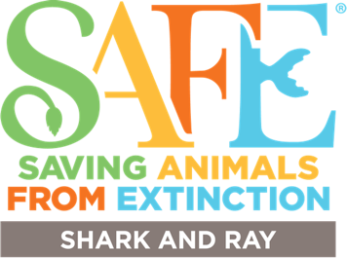
Statement of Financial Commitment
Saving species costs money! By fundraising and donating to SAFE Sharks and Rays you are helping to support our ambitious, global plan to save imperiled species.
We value your support and acknowledge and recognize our donors in a variety of ways. Funding contributions are welcome at a variety of levels and are cumulative over the 3-year plan.
- Platinum - $20,000+
- Gold - $10,000-$19,999
- Silver - $5,000-$9,999
- Bronze - up to $4,999
2024 Donor recognition and acknowledgement includes the following benefits:
Bronze - Certificate of Partnership, logo placement on digital materials
Silver - Bronze level + one-hour, online, SAFE conservation engagement training for staff/volunteers
Gold - Silver level + recognition plaque, logo placement on printed materials, customized annual report
Platinum - Gold level + on-site, SAFE conservation engagement training for staff/volunteers (at facilities

Date:
Organization:
Contact Name:
Email:
Donation Amount:
One-Time Donation: Recurring:
expense), customized acknowledgement video
READY TO DONATE?
Click HERE for online donations via credit card, PayPal, or bank transfer. Donations are tax-deductible.

For check deposit, please make payable and send to:

AZA SAFE Sharks and Rays/Seattle Aquarium
1483 Alaskan Way, Pier 59, Seattle, WA 98101-2015

